**Basic authentication –** It is justa encoding, not encrypting or securing in real.

**https://www.youtube.com/watch?v=_myz6jahdQA**

Existing service –

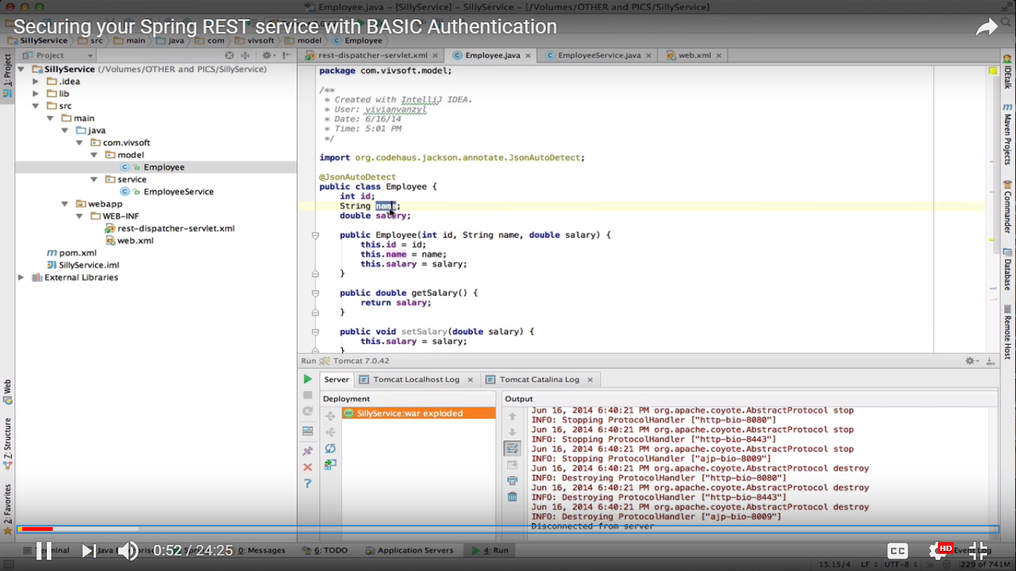

Implementation – definition of my service -

With CRUD operations



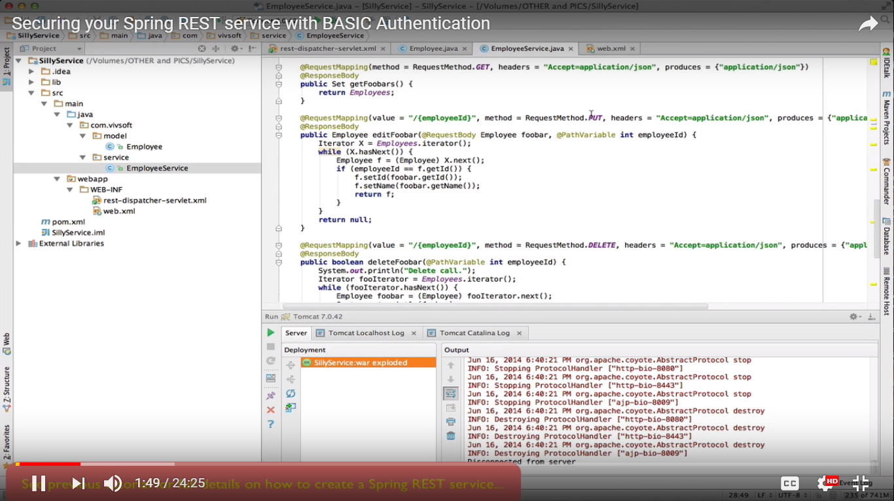

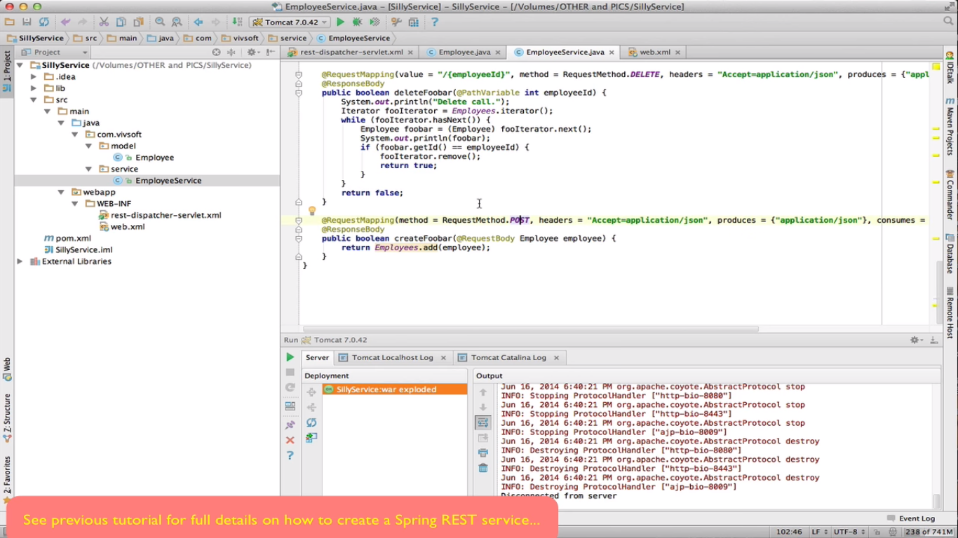

Web.xml –

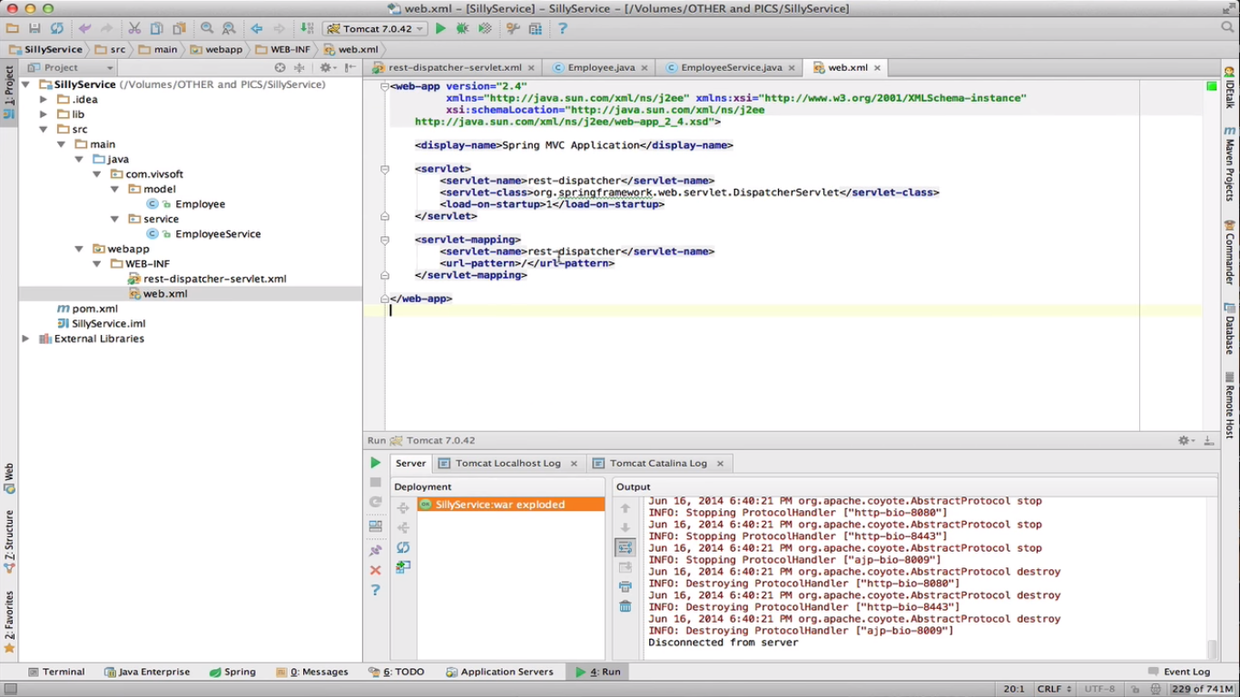

Handler mapping – config file -

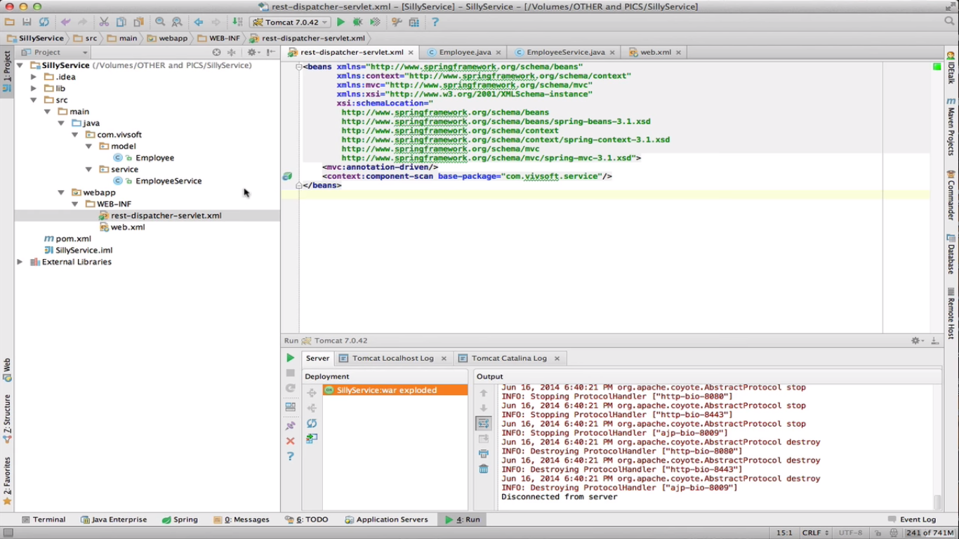

Sample API (GET) calls -

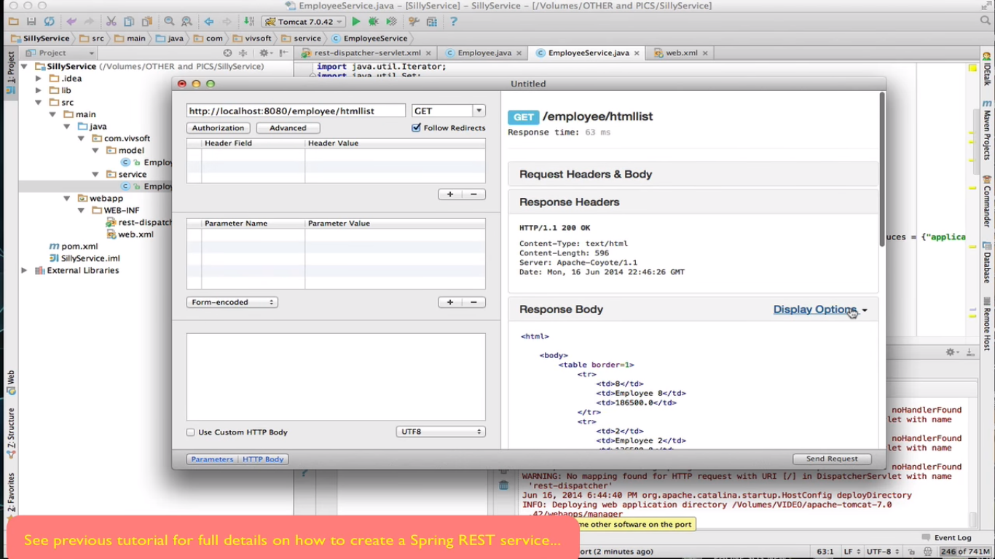

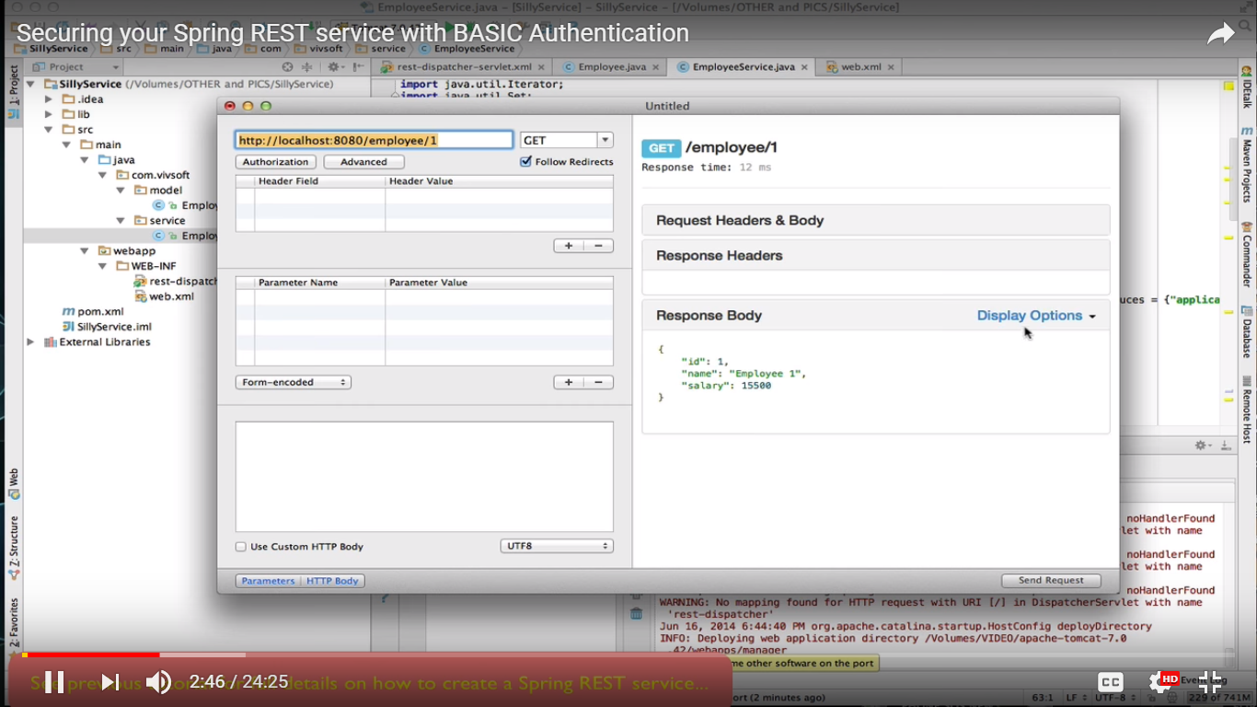

Service should now stop getting misused by few Bad Clients – i.e. add basic authentication to it with username and password -

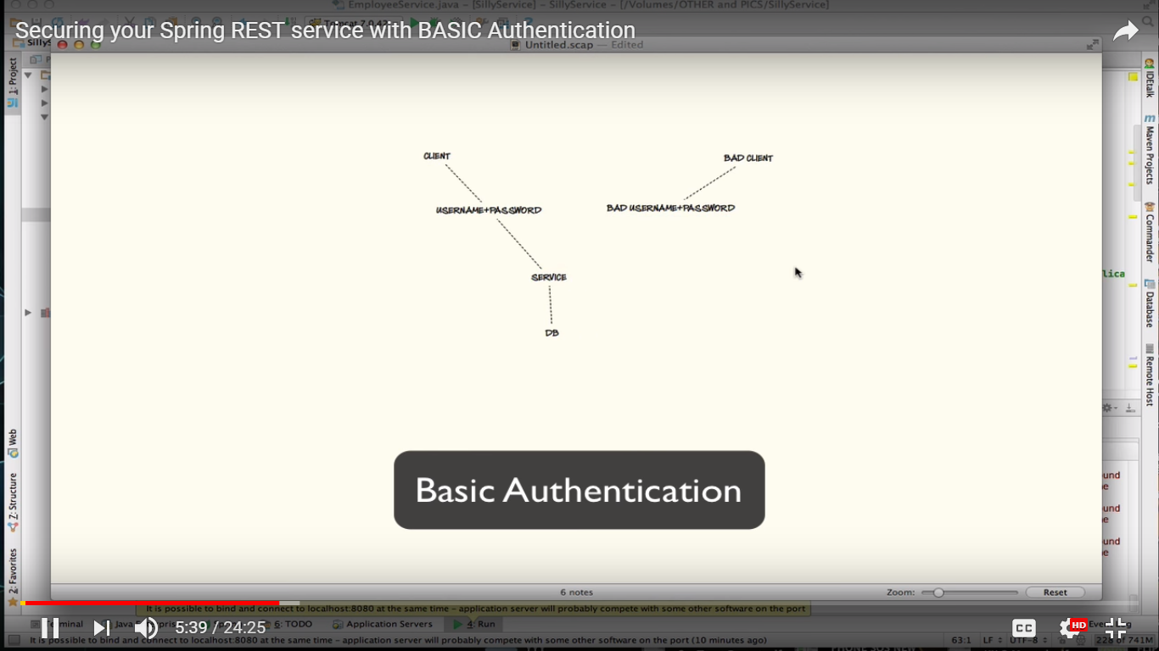

Create a new configuration file -

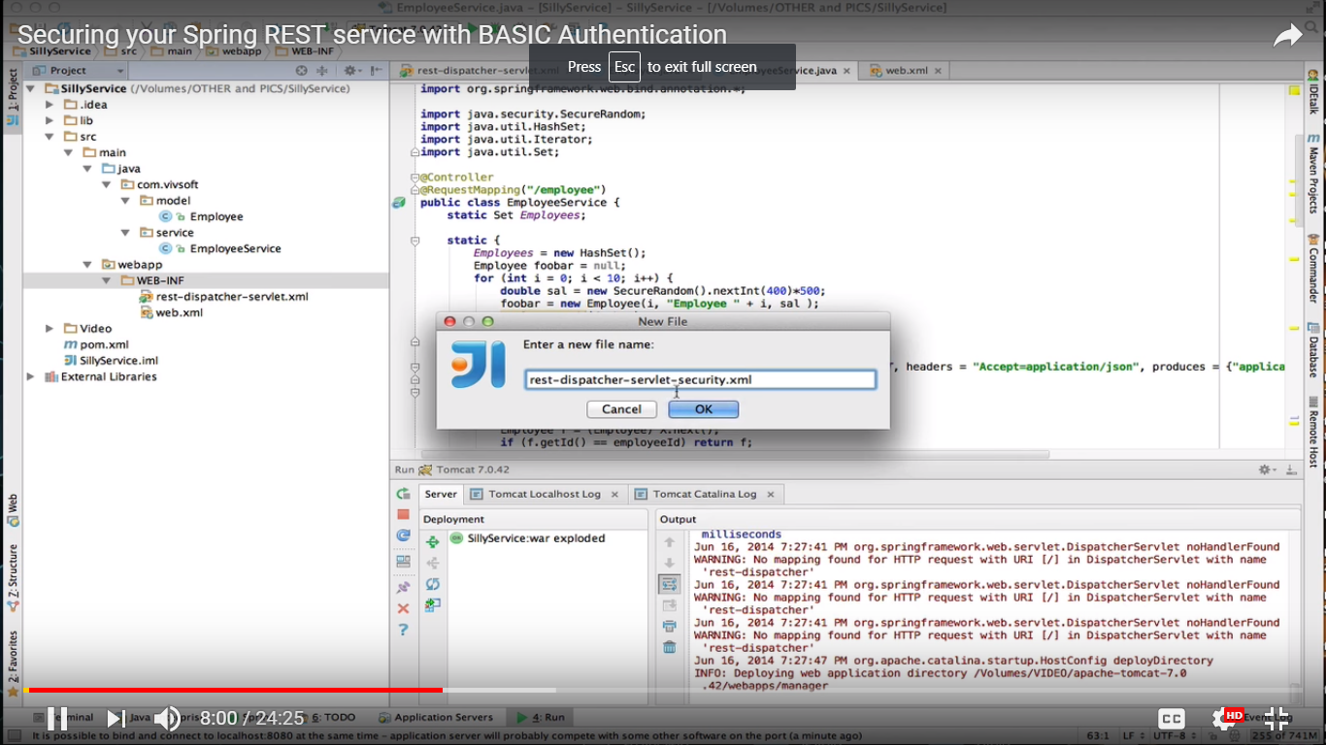

Notice security section with (user) details and this is applied on pattern /** (root url onwards).

We could store these user credentials in some external config file/ DB/ LDAP instead of storing it in flat file as shown below -

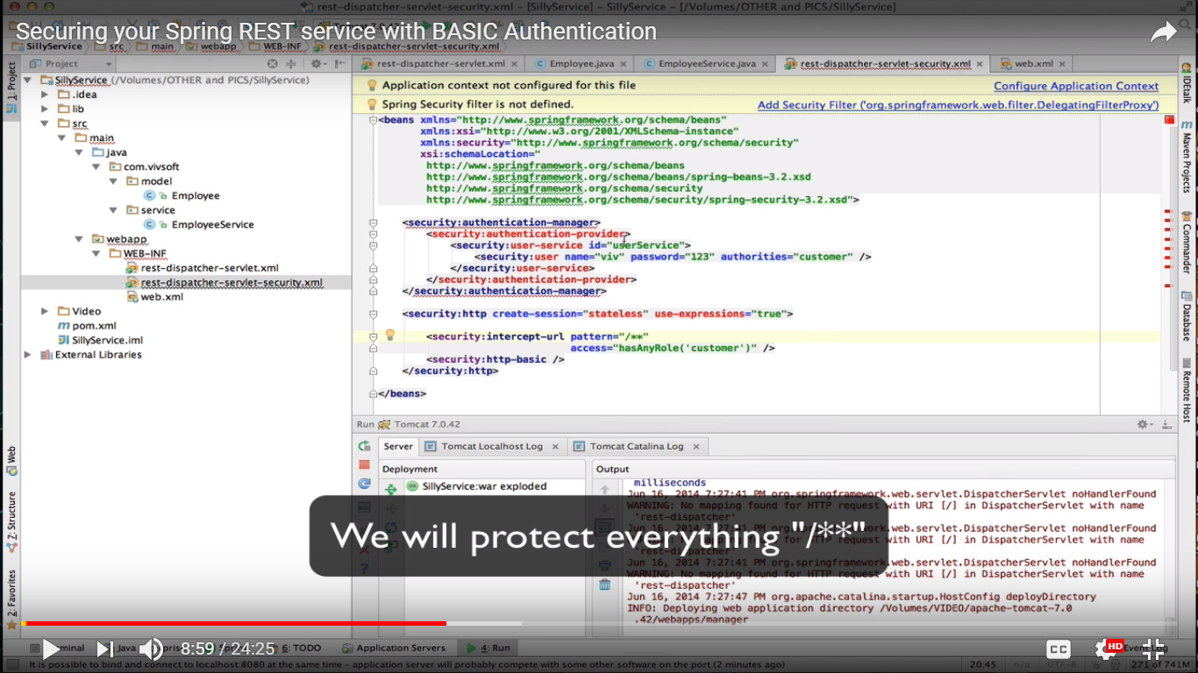

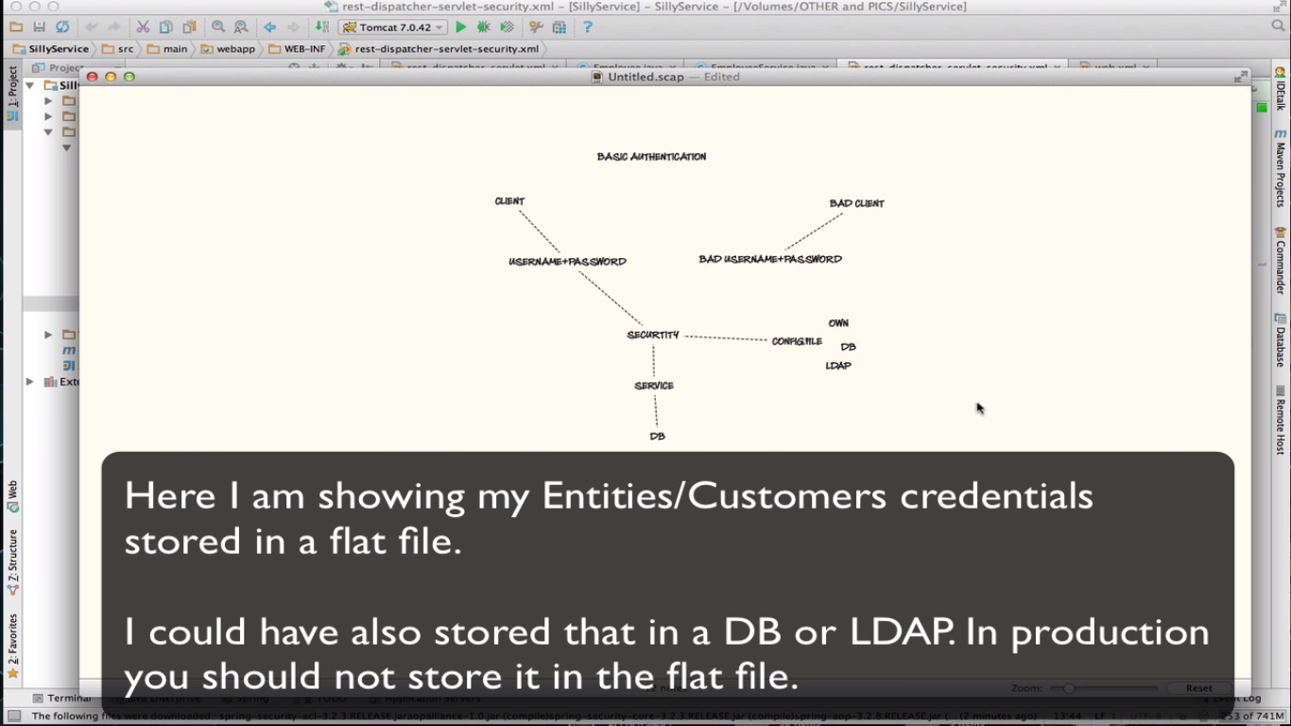

Add security libraries (jar) to build path – 4 jars needed – either from maven or locally downloaded jar files -

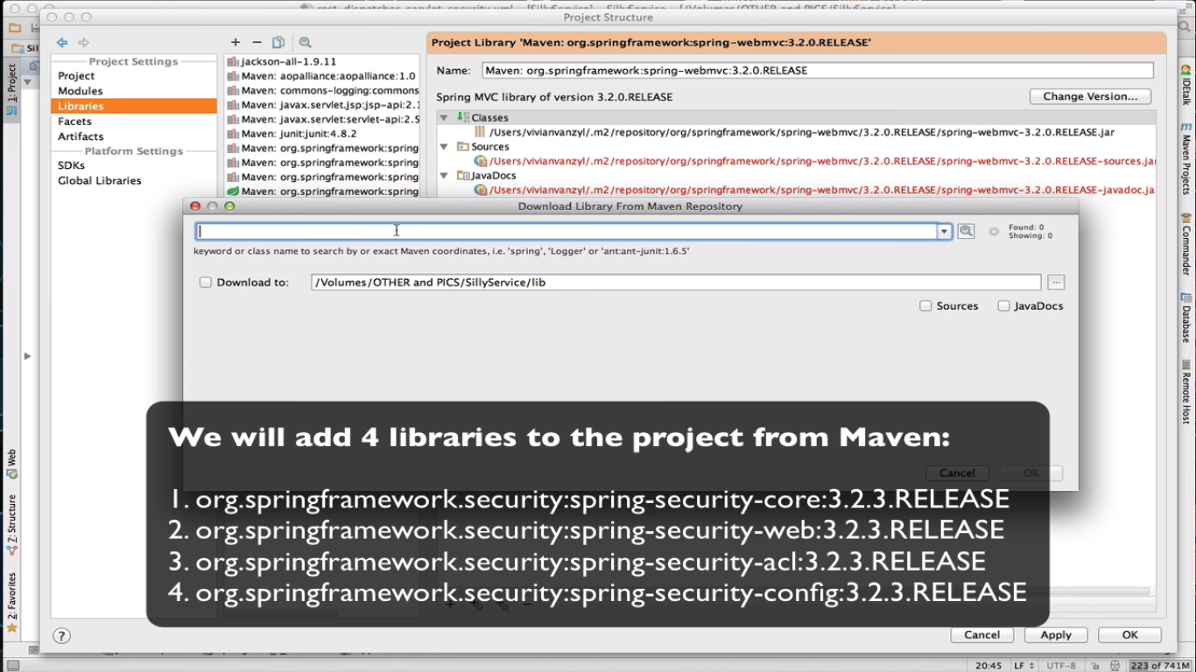

Make the libraries available to our artifact (war) file at runtime -

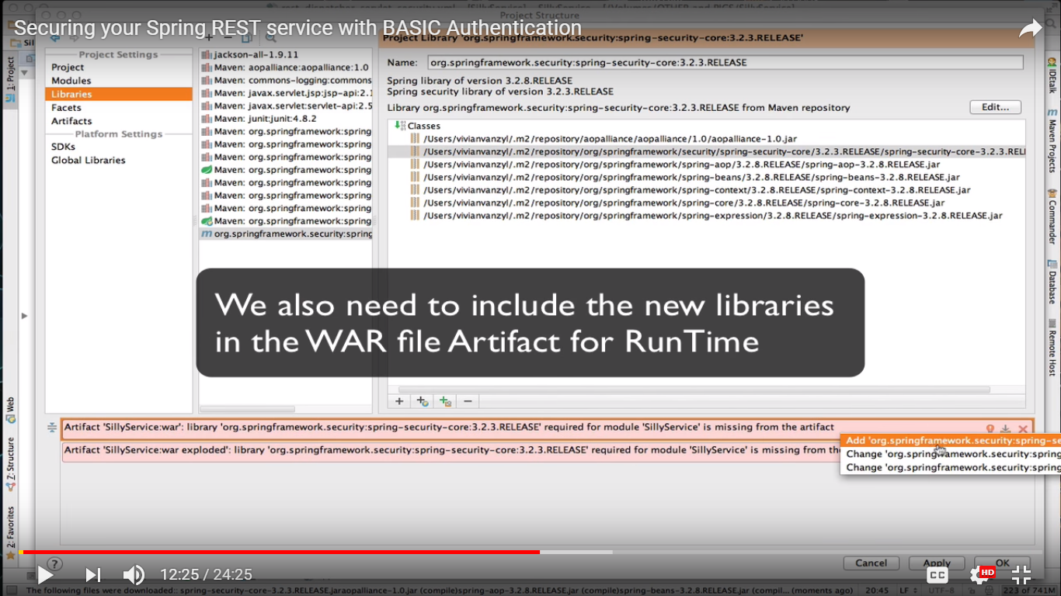

All errors from config file are gone –

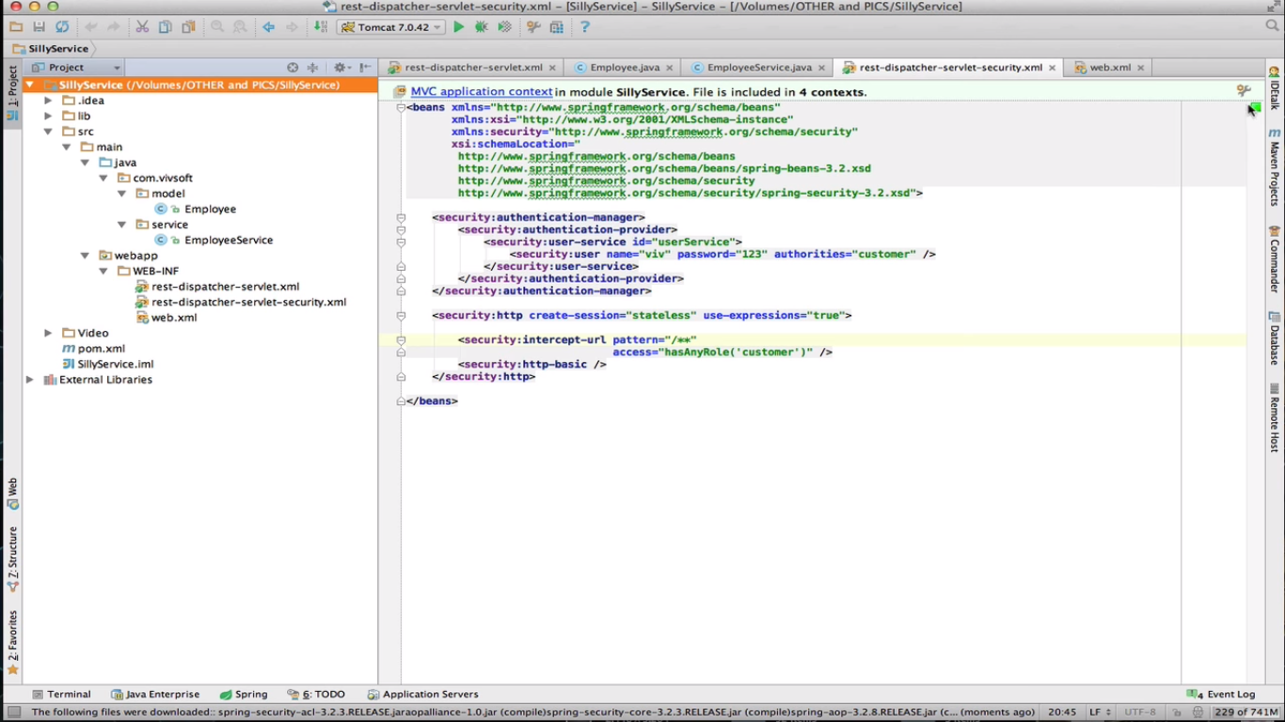

Make entries for config files in web.xml –

This part stays as is –

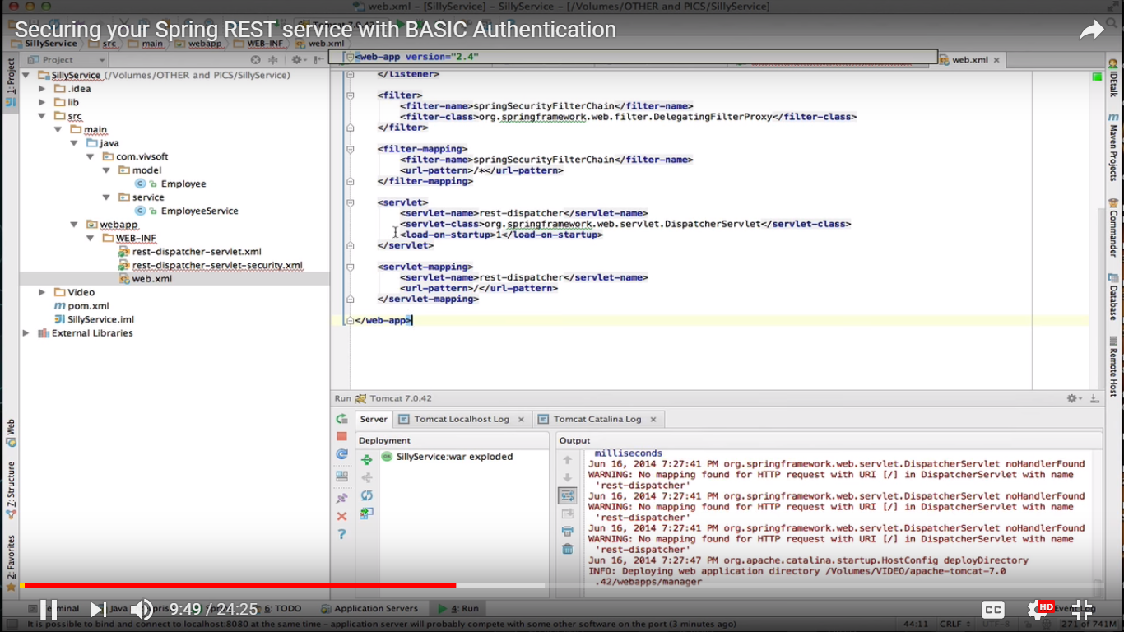

We add few additional things as follows –

- add filter – springSecurityFilterchain with corresponding class

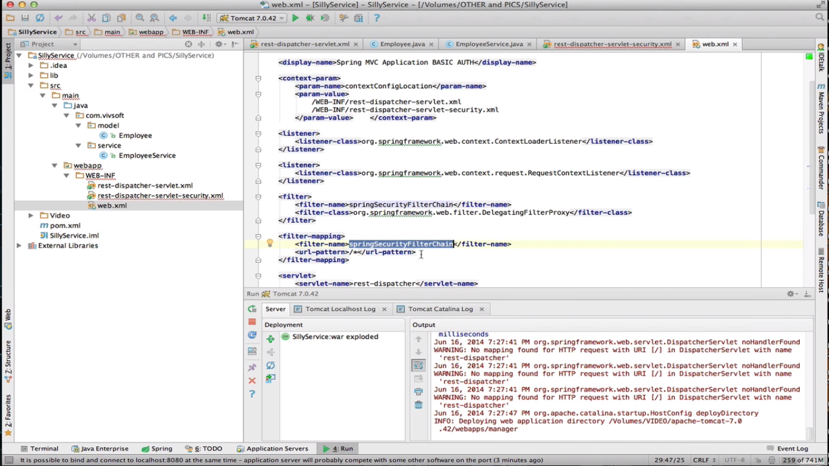

If there are further build path issues –

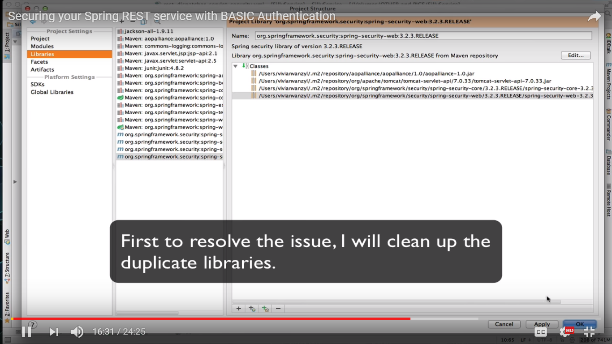

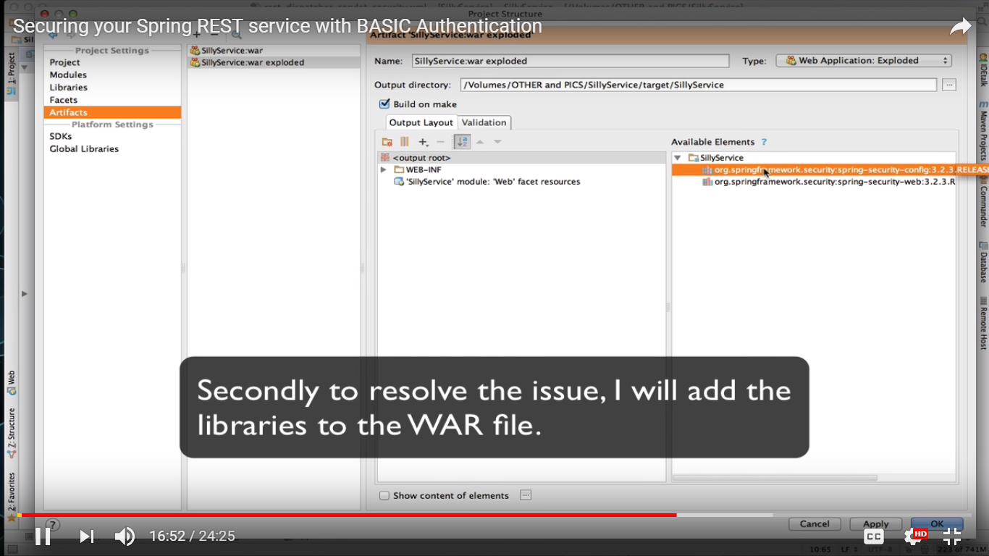

Calling the service -

Now if you try to call/ hit the service through test client like postman – without username and password, we will get authentication error.

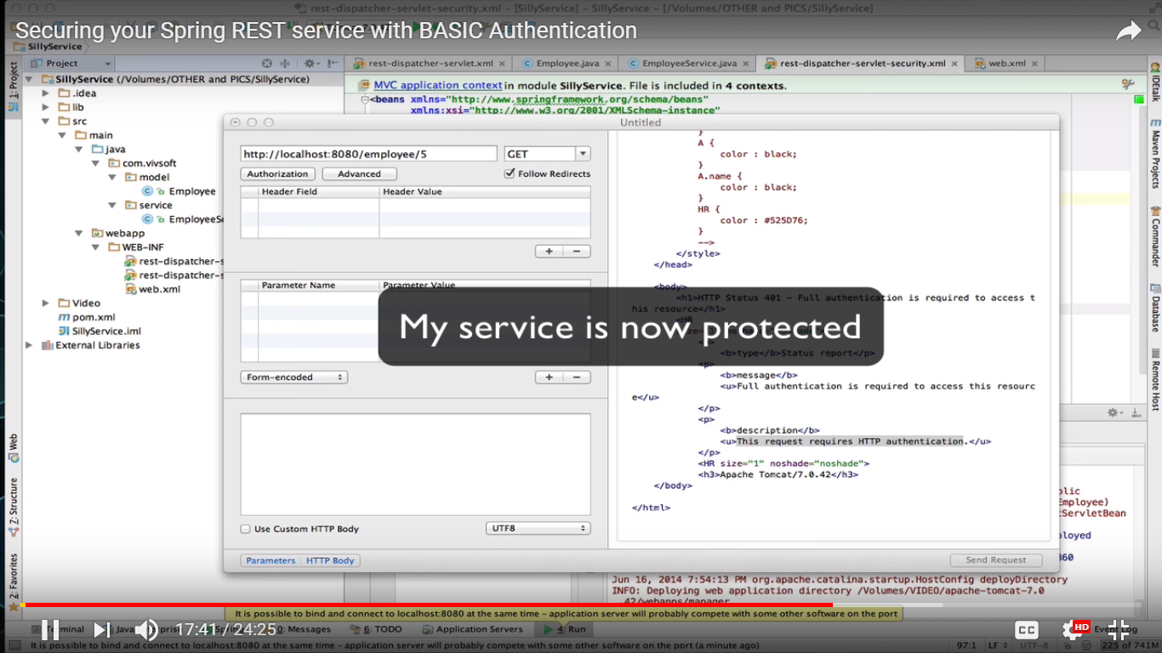

If you send basic authentication (username and pwd) through Authorization tab – then it works fine provided they’re correct. It will add “Authorization” header with keyword Basic <someValue> in “Headers” section.

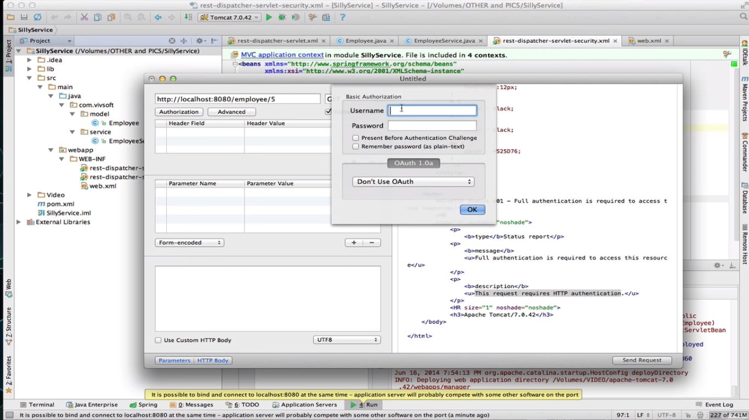

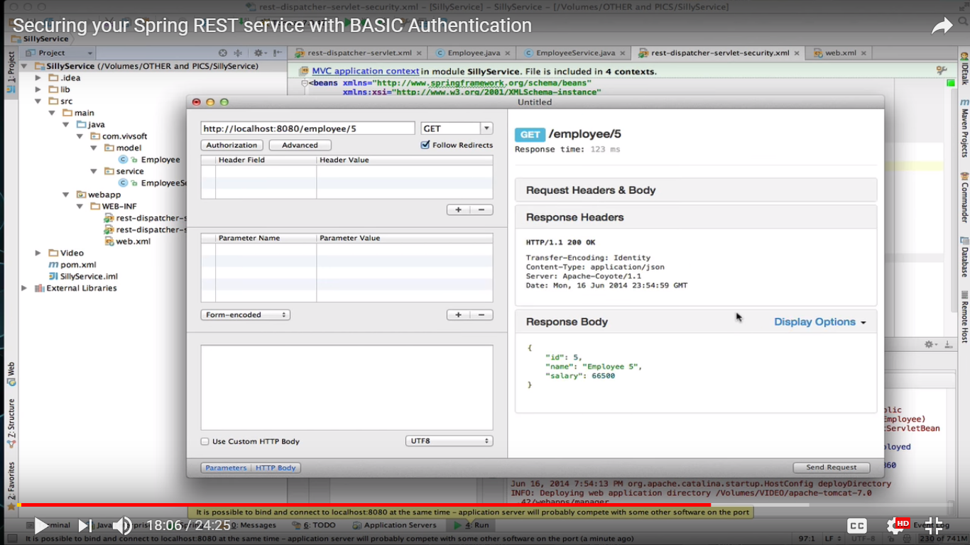

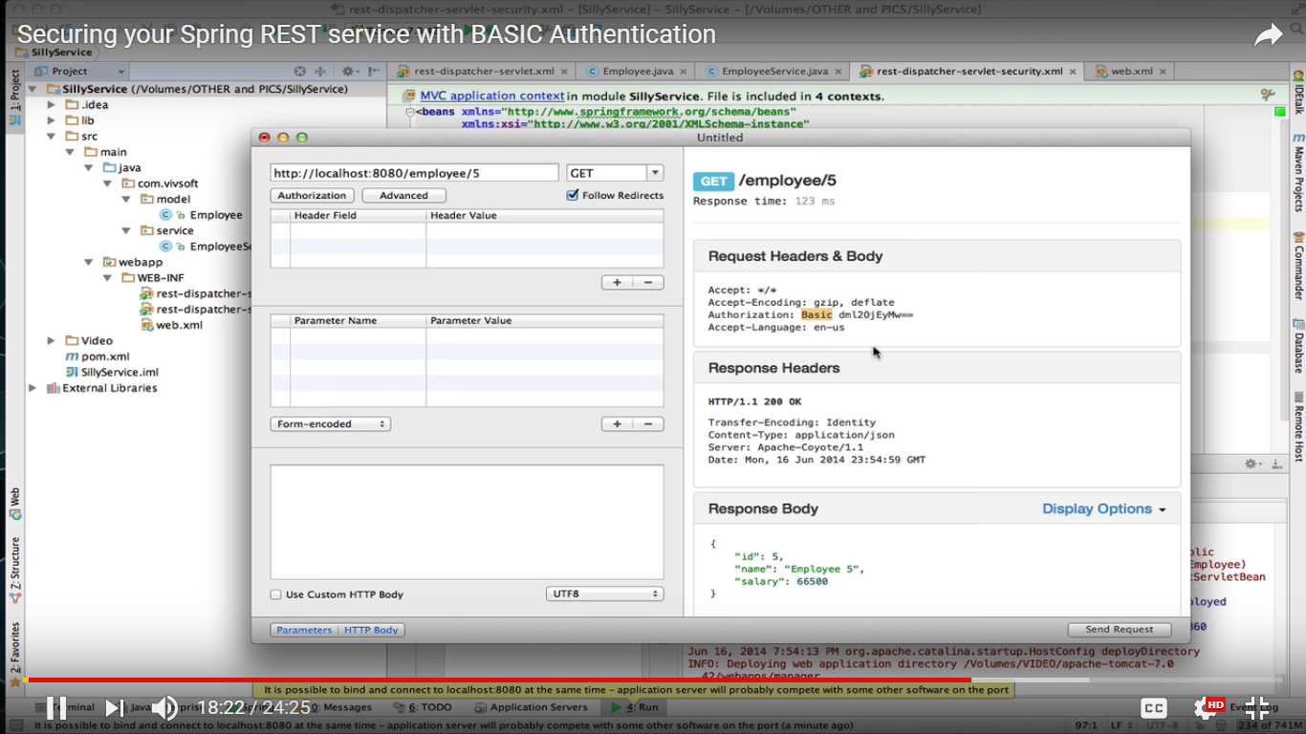

You can use this authorization further – It is Base 64 encoded.

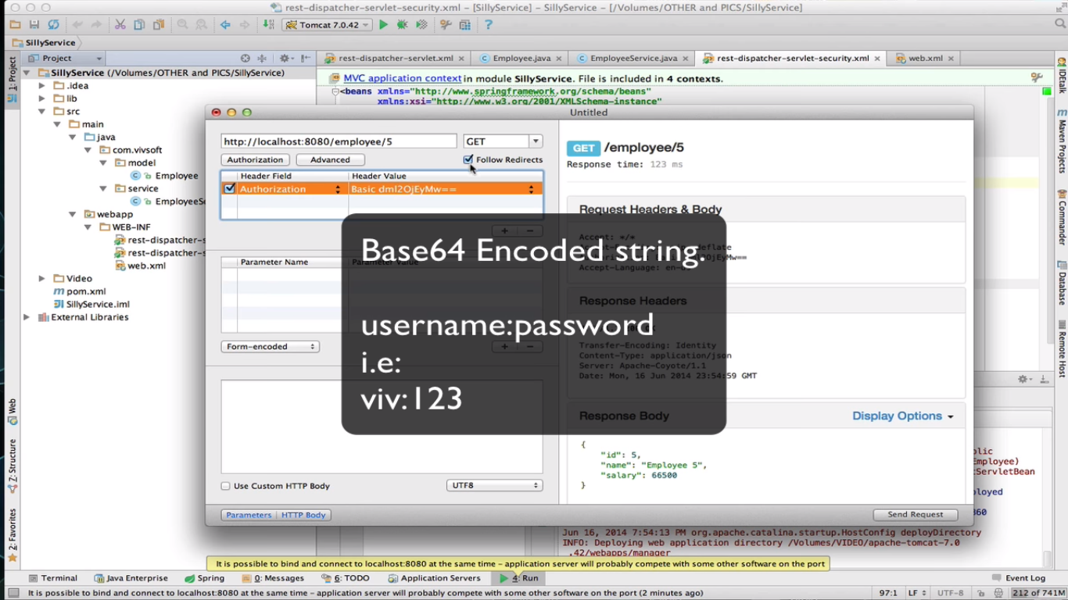

Base 64 encoding- we ourselves can do it – or to prove it we can create a small utility –

Base 64 encodes the “username:password” string in a http compatible format (so that all browsers understand it).

Create a class –

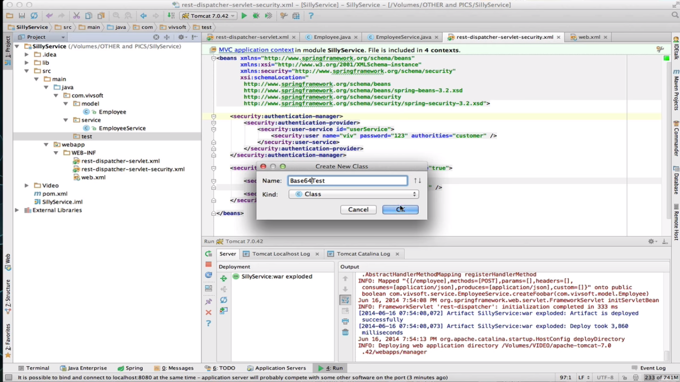

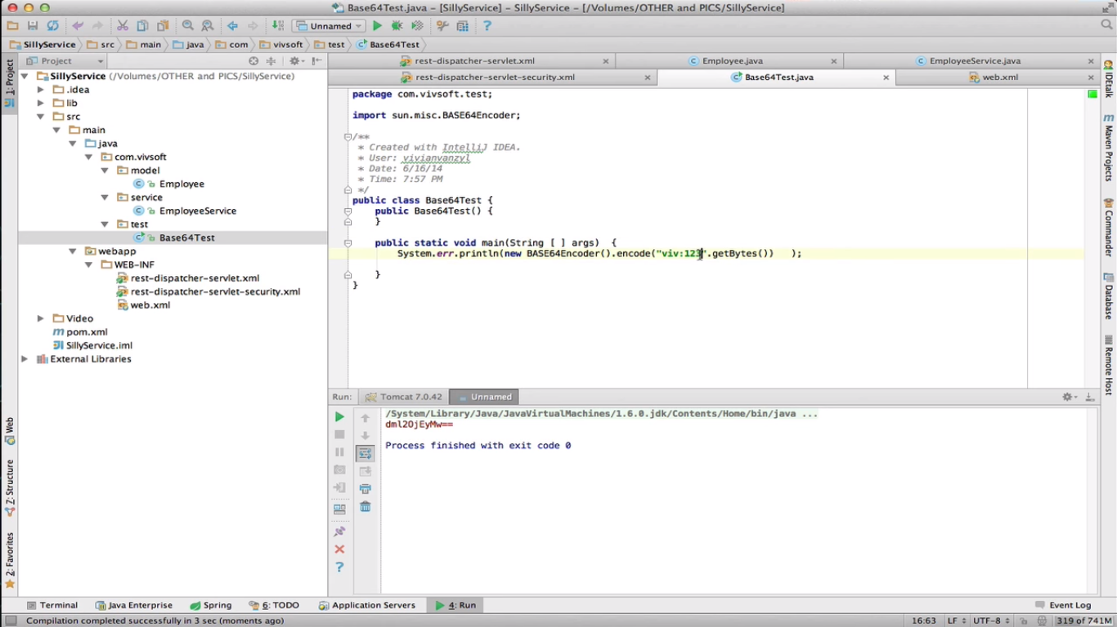

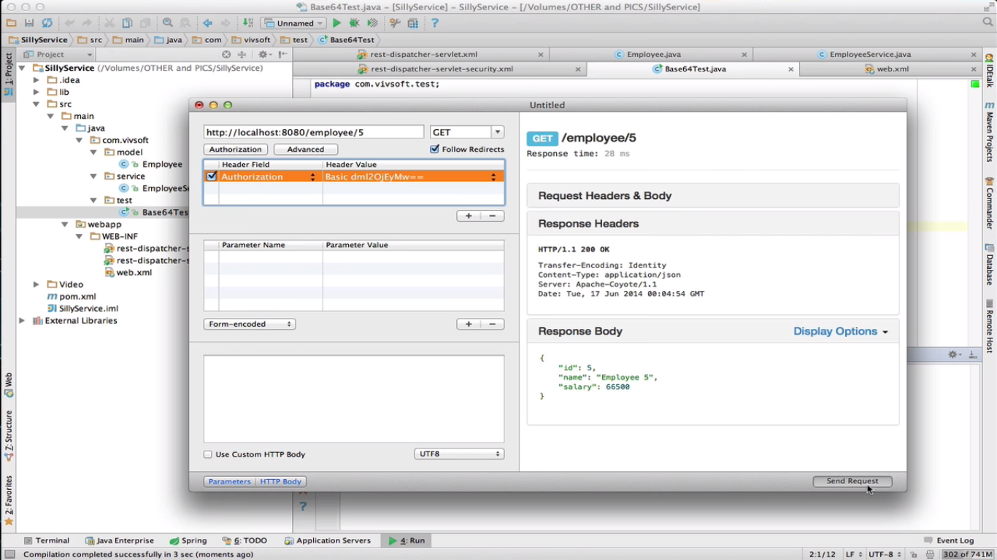

We can encode any such pairs –

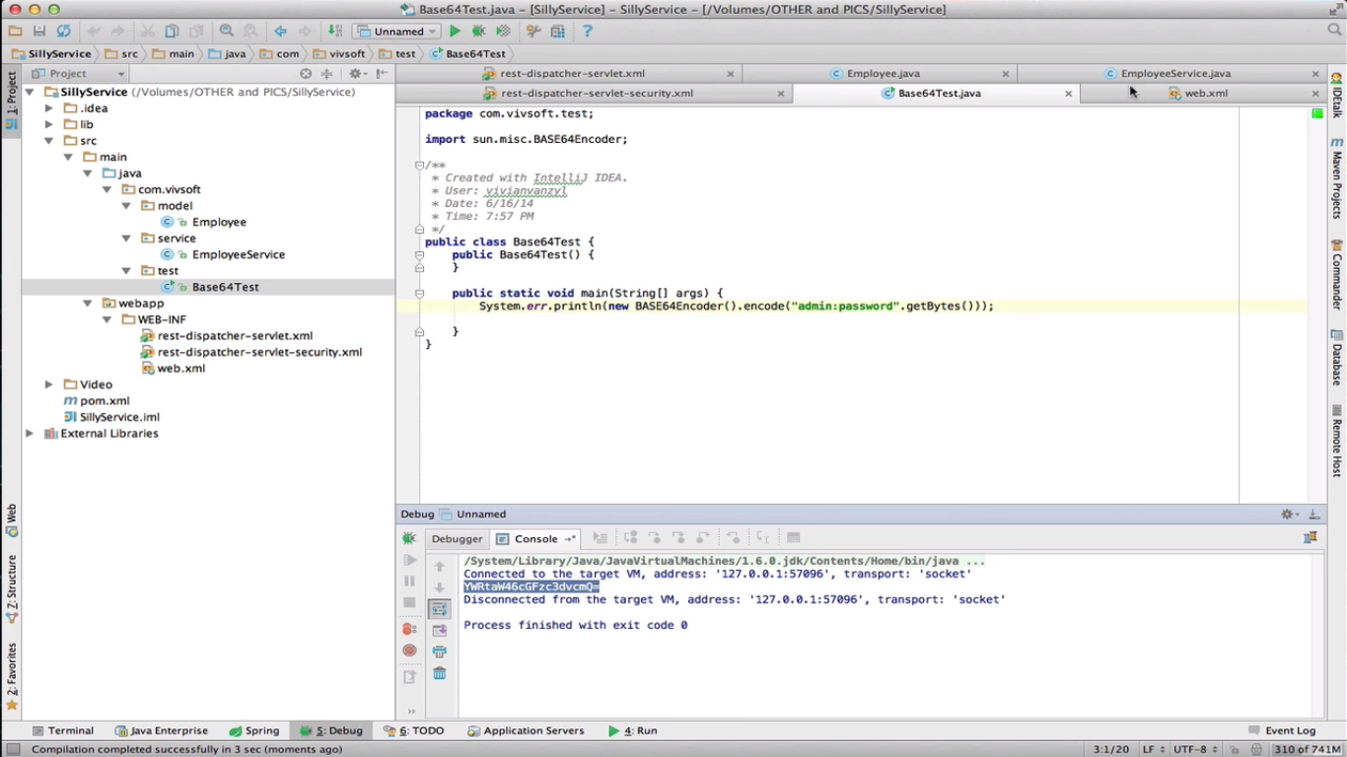

Use it –

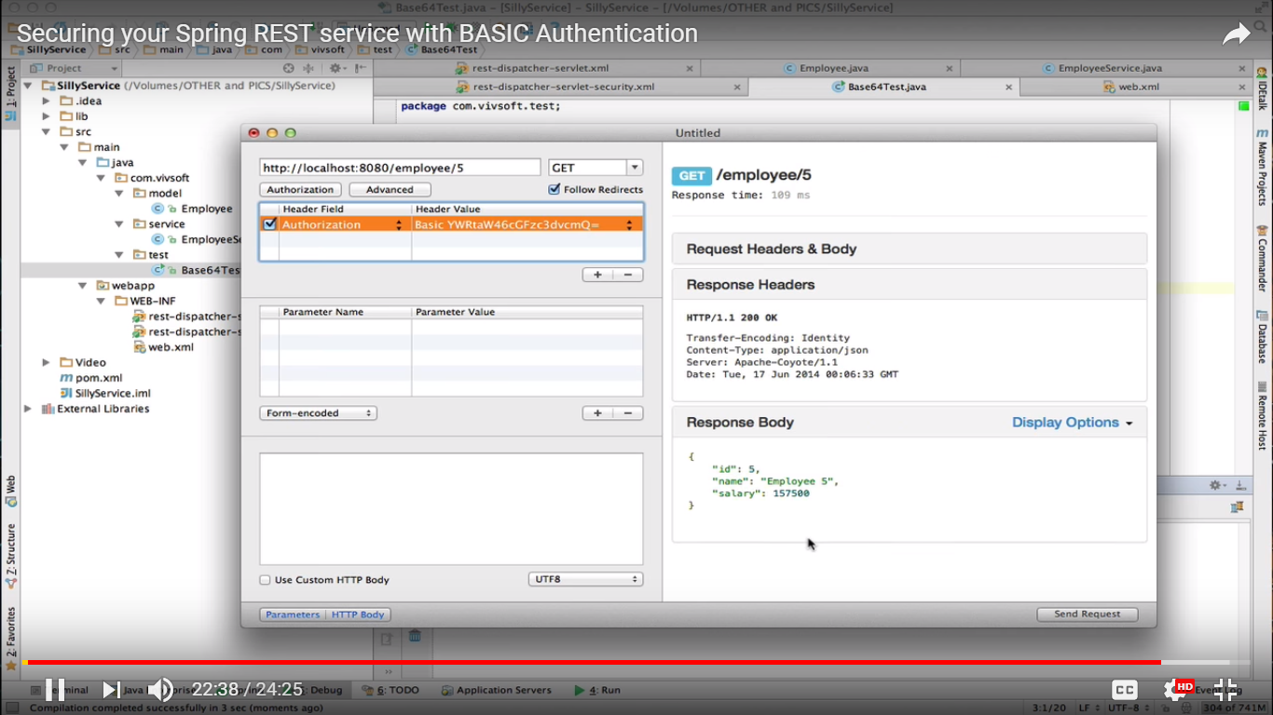

Disadvantage –

As the base 64 encoded username and password are sent over network via request headers, it is quite easy to decode it and use by a sniffer. So it’s not actually secure or encrypted.

It’s always better to send them over SSL (or https) so that it little safe.

